

**May Good News 2024**

**Our ministry vision for the Virginia Annual Conference is *“to be disciples of Jesus Christ who are lifelong learners, who influence others to serve.”***



**From Pastor Adam**

**May This Be the Best of Mays”**

“*I can do all things through Christ who strengthens me.”*  (Philippians 4:13)

We get the month name *“May”* (as with many month names) from the ancient Romans. May was the name linked with the ancient Roman goddess of flowering plants. It is easy to see why the ancients made this connection. After all, May as we experience it in North America is the very month in which the floral wonder of life springs into action and we witness the grandeur of God’s design anew and afresh. Still there is more. May is not merely a month, you see. May also carries the sense of an action word. Many of the benedictions and declarations of the church begin with the word “May” – “May the Peace of the Lord be with you always.” – “May the road rise to meet you up, may the wind be always at your back.” – “May you go forth into the world in the strength of the Spirit.” The pop musician Rod Stewart used the word “May” in a powerful and prayerful wish for his son in the song “Forever Young” – “May you grow to be proud, dignified, and true.” May is a word filled with promise and possibility. It is a charge to go forth, to do, to love, to share, to care, to prosper, to celebrate, and to live robustly. The word “May” hints that the impossible might just be possible. I hope we hear something of the resurrection in that. When God raised Christ from the dead the miraculous was unleashed upon the world, and now the whole of life shines with new splendor, and a new sense of what great things might be, and what wonders may come. May this May be the best of Mays for you! And may you be filled with the power of the resurrection!

God bless you my friends! Adam

Circle News****

The Wesleyan Group …will meet on Monday, May 13th, at 6:30 p.m., at Charley’s.

~*Ann Robbins*

The Merry Marthas Circle will meet on Thursday, May 23rd, at 10:30 a.m.,

to pack Kits for Conference. Judy will bring all supplies. Lunch afterward at Charley’s. We will not have regular meetings in June, July, and August.

~*Judy Robertson*



**The choir** will be singing on Sundays, May 19th and 26th. We will be rehearsing at 10:00 a.m. We will sing familiar hymns so please come join us!

*~Heather Wilson*, Director of Music

*Mission Moment*

For the month of April the PVCM cart contained 39lbs. of food and hygiene products. As always they were very grateful for our faithful support. The Mission committee thanks everyone who continues to support this outreach project. We will continue to collect pop-top cans of food along with deodorant (most needed), shampoo and body wash.

~*Linda Jessen & Mission Committee*

**Food Cart: May**

Pop-top cans of meats, soups, pasta dishes, vegetables, shampoo, body wash, and deodorant. *No* ***“baked goods”*** *!* *Place donations in the grocery cart, located in the Commons*.



We received $3,565.00 for our Easter Offering 2024. We appreciate you for your continued support of our church!

*The Mountain View District*

invites you to celebrate our District Superintendent

**Rev. Denise Bates**

On her retirement from Ministry.

Sunday, May 19, 2024

Bethlehem UMC, Moneta, VA

4 - 6 p.m.

Cards and donations to the Henry Fork Service Center will be collected and presented to Denise at the reception.

**Congratulations...**

*Katie Jessen and Andrew Bodamer* were married on April 27, 2024 in Bedford, Va.

Katie is the daughter of Jennifer Jessen and the Granddaughter of Linda and George Jessen.

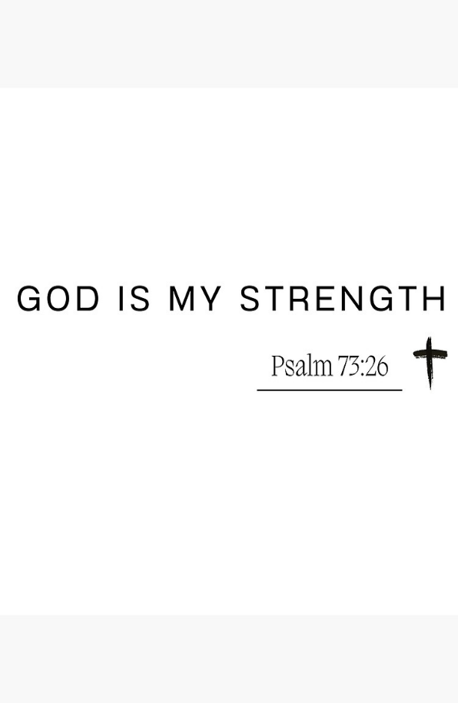



Dear Chestnut Hill Family,

*Thank you so much* for the wedding reception part of the Stewardship & Valentine’s Day lunch! What a thoughtful and kind gesture! We felt the love (even though Jeannie was away that Sunday). The treats and decorations were great fun! We are most blessed to be a part of the CHUMC family.

Much love, ~*Adam & Jeannie White*

* * * * * * * * * * * * * * * * * * * * * * * *

*I am so thankful t*o be a part of Chestnut Hill United Methodist Church .  Since my collapse at home, hospital visit, rehab at the Summit and move to Bentley Commons, I have received numerous get well wishes.  I send thanks to each and everyone for visits, cards and phone calls expressing their love and get well wishes.  Many thanks to Pastor Adam for his visits and prayers, and to

Monica for her continued support.

May God richly bless you all. ~*J. Owen Stinnette*

**Address Change:**

J. Owen Stinnette

Bentley Commons, Apt. 339

1604 Graves Mill Rd., Lynchburg, VA 24502

* * * * * * * * * * * * * * * * * * * * * * * *

My Chestnut Hill Family,

*I wish to thank you all* for the many thoughts, prayers, beautiful cards, food, phone calls, and visits. God showed his love through all of you and we are truly grateful! We miss you all terribly and love you all so much. Always look to God for everything, giving much thanks and praise. Hope to see you all soon. Can’t wait to spend eternity with you.

Love always, ~*Jody Underwood & Family*





1 Kim VandeBogart

4 Shaun VandeBogart

6 Tommy Mason

8 George Jessen

12 McKenna Mason

16  Rev. Elizabeth Ecklund

18 Jordan VandeBogart

20 Kennedy Ecklund

21 Barbara Blunt

22 Carolyn Anders

23 Robbie Perrow

27 Susan Blunt

28 Robert Hicks

Kelly Mason

29 Tucker Cole

31  Dean Burgess



**Sunday,**

**May 12, 2024**

May 2024

|  |  |  |  |  |  |  |
| --- | --- | --- | --- | --- | --- | --- |
| **Sunday** | **Monday** | **Tuesday** | **Wednesday** | **Thursday** | **Friday** | **Saturday** |
|  | | | **1** | **2** | **3**  10:00am Homeschool | **4**  12:00pm Homeschool Festival of the Arts |
| **5 *Sixth Sunday of Easter***  9:30am Sunday School  10:30am Worship | **6** | **7** | **8** | **9**  1:00pm Peaks View Clergy Lunch & Learn | **10** | **11** |
| **12 *Seventh Sunday of Easter***  ***Mother’s Day***  9:30am Sunday School  10:30am Worship | **13**  6:30 pm Wesleyan Group @ Charley’s | **14** | **15** | **16** | **17** | **18** |
| **19 *Pentecost***  9:30am Sunday School  10:00am Choir  10:30am Worship | **20** | **21** | **22** | **23**  10:30am Merry Martha's | **24** | **25** |
| **26 *Trinity Sunday***  9:30am Sunday School  10:00am Choir  10:30am Worship | **27 *Memorial Day***  Church Office Closed | **28** | **29** | **30** | **31** |  |

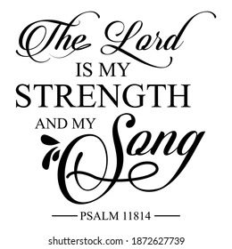



1 Pat Short

2 Nancy Lee

Emily V.

Fernandez

3 Michael McGlothlin

6 Kirsten Bell

Tim Crist

Dennis Tolley

7 Kenny Busic

Cheryl Powell

9 Owen Stinnette

Jeremey

VandeBogart

11 Landen Glass

12 Camden Mason

14 Wade Ware

16 Burton Brooks

Terry Palazzi

Anne-Elaine Tiller

17 Suzanne

Marshall

Blake Phillips

18 Sharon

Rickmon

19 Connie Yost

20 Erin Ecklund

21 Steven Kinzer

22 C.O. Bell

25 Frankie

Hardwick

28 Jacqueline Busic

Cheryl Thomas

29 Wes Robbins

Ricky Smith

31 Robert Baunach

**2022**

**March 2022**

**Those Who Serve ~ May**

**GREETERS:**

May 5 ~ Maggie Musgrove

May 12 ~ Jane White

May 19 ~ Mary Walker

May 26 ~ Dan Robertson

**Our Church Financial Picture**

Through the end of March 2024

General Operating Funds:

Needed to meet our 2024 Budget $ 197,677

Needed to meet our budget to date $ 49,419

Actual receipts to date $ 48,866

Overage to meet budget to date $ 553

Actual expenditures to date $ 42,824

Overage to meet expenses to date $- 6,042

Joy In Missions Funds

Our Giving Goal for 2024 $ 8,600

Needed to meet our goal to date $ 2,150

Actual receipts to date $ 2,940

Special Offerings* (not budgeted):

Received to date $ 4,580

Dispersed to date $ 1,145

*Christmas, Easter, Annual Conference,

World Communion, etc.

**2024 Joy In Mission Donations**

To date, the following amounts have

been paid to the missions indicated.

Budget Spent

1. Missionary Covenant Relationship

$1,000 $ 1,000

2. Park View Mission, Food for Families

$3,000 $ 3,195

3. Society of St. Andrew $1,000 $ 1,000

4. Blue Ridge Area Food Bank $1,000 $ 1,000

5. Daily Bread $ 500 $ 125

6. Good Neighbor $ 500 $ 0

7. Habitat for Humanity $ 500 $ 125

8.. UMCOR-Non-Administrative $ 500 $ 0

9. Undesignated $ 600 $ 0

10. Meals on Wheels (Souper Bowl) $ 755

Thank you for your generosity.

**GOOD NEWS** is

published monthly for members and

friends of Chestnut Hill United

Methodist Church. Send articles to

the church office by the 15th of the

month. (Subject to change).



-copied



January 2022

**2022**





**April 2022**

**April 2022**

**March 2022**

*Chestnut Hill United*

*Methodist Church*

4660 Fort Avenue, Lynchburg, VA 24502

Phone Number: 434-239-8423: FAX: 434-239-7209

E-mail: [chestnuthillumc@comcast.net](mailto:chestnuthillumc@comcast.net)

On the web: www.chestnuthillumc.net

Church Office Hours

**Monday-Thursday~**9:00 am—3:30 pm

**Friday~**9:00 am-1:00 pm

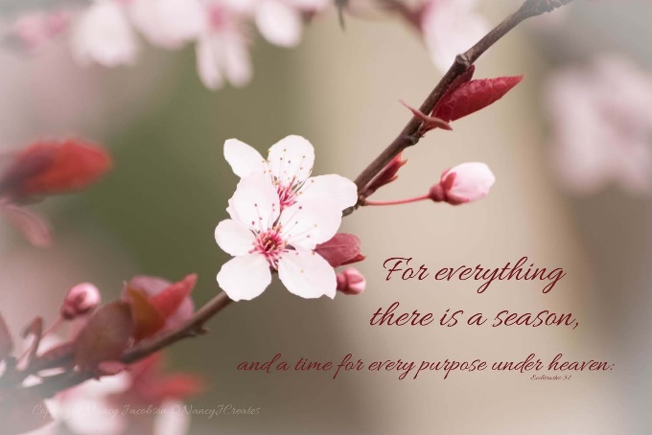

***DIRECTORY OF***

***CHESTNUT HILL UNITED METHODIST CHURCH***

|  |  |  |
| --- | --- | --- |
|  | Sue Haupert-Johnson | Richmond Area Resident Bishop |
|  | Denise Bates | Mountain View District Superintendent |
|  | Adam White | Minister |
|  | Erin Long | Associate Minister |
|  | Monica Campbell | Administrative Assistant |
|  | Heather Wilson | Director of Music Ministry |
|  | Judy Martin | Bookkeeper |
|  | Judy Robertson | Lay Leader |
|  | Elizabeth Nichols | Missionary in Henry County |